Email Pupils
Pupils will be able to email their class teacher through purple mash. This will be used for discussing work or asking important questions. Teachers will not necessarily respond instantly and this should be understood, however they will respond to pupils as soon as possible, taking staff absence and access into account.
Step 1: Log in to PurpleMash www.purplemash.com/aveley
Step 2: Go to ‘tools’ and then find ‘2email’ which can be found under ‘Communicating and Sharing’.
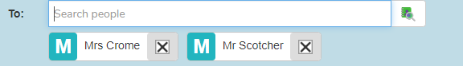
Step 3: Pupils can search for their teacher in the ‘to’ bar. (If they have more than one teacher, they can add these).

Step 4: Compose message and send.
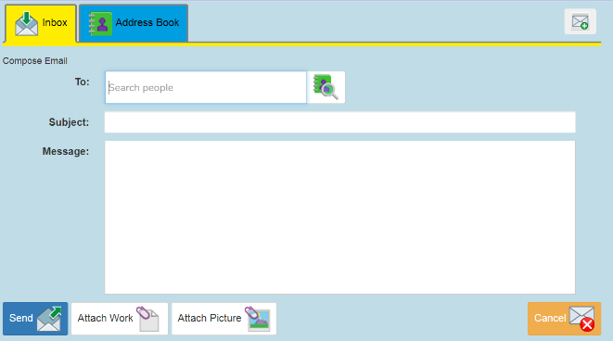
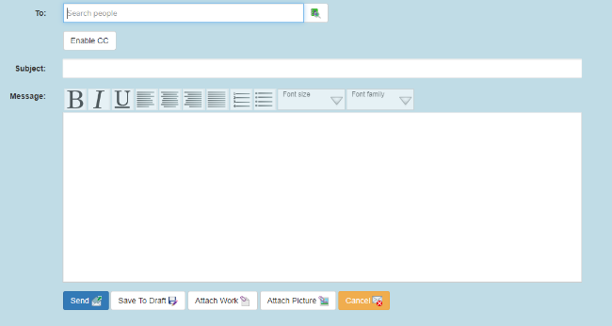
*Pupils are not able to email each other, any messages sent will not be delivered*
KS2 Example Screen KS1 Example Screen

